Level 2 -> Level 3

The goal of this level is to find the pass. to log into <http://natas3.natas.labs.overthewire.org>.

Username: natas3

After logging into level 2 we got a hint to get the password of next level. The hint is **“There is nothing on this page”**

The image is not displayed along with the hint. So, we will check the url of the image in the source code. URL of the image is “files/pixel.png”.

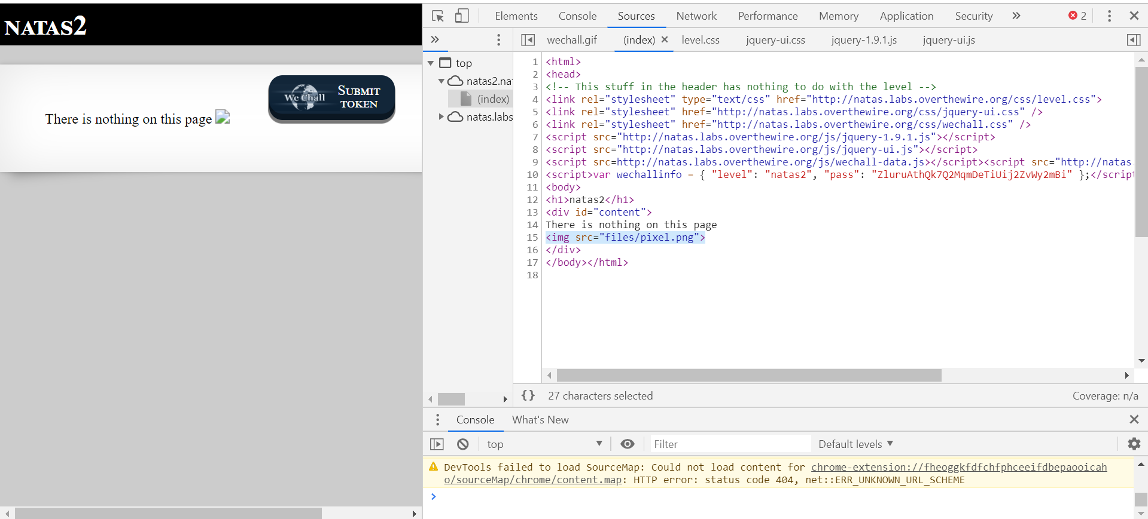

We will go to <http://natas3.natas.labs.overthewire.org/files>. Along with the pixel.png file, users.txt file is also present which may contain the password. Navigate to the users.txt file.

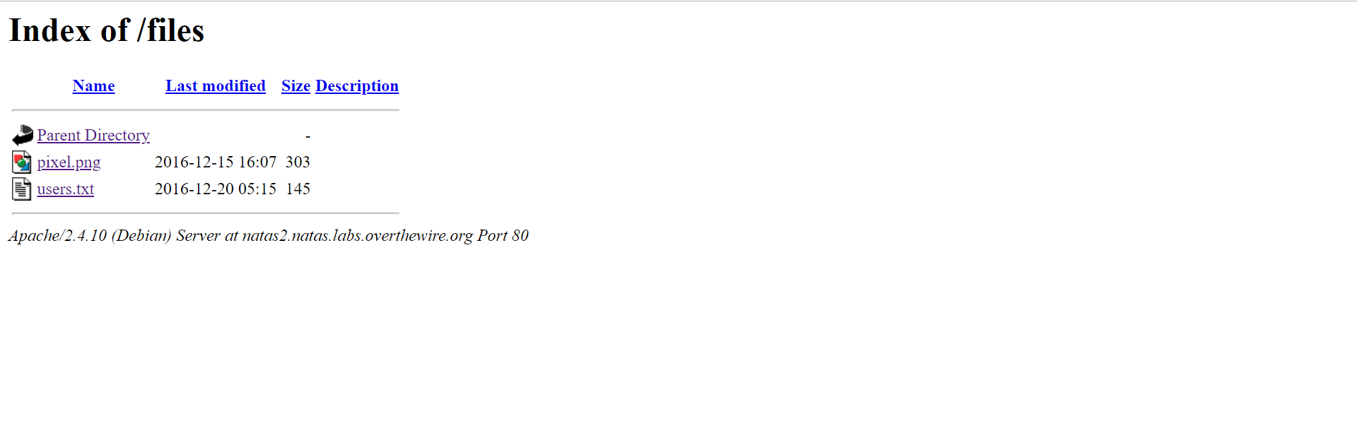

And here is the password.

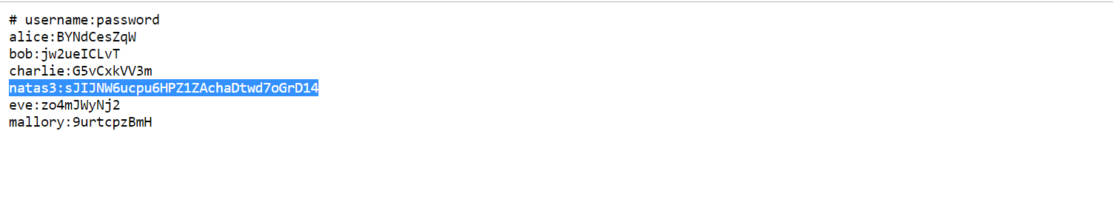

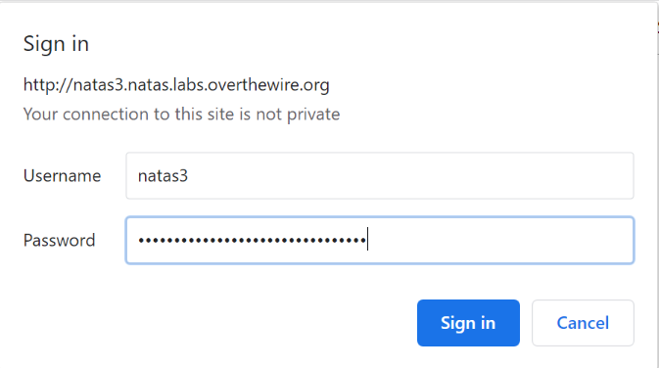

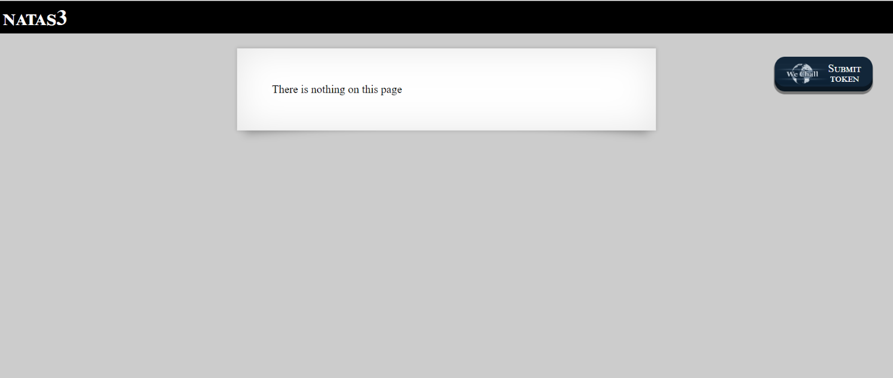

Successfully passed level 3.…